Our next duty was to design the boat. This was the toughest task for us in the whole project. First we developed a boat like image using six points and six lines that joins the points in proper manner so that it should look like a boat. But to implement the boat in proper way we have used many points at the proper place on the blue window. By joining all the points in proper manner, the boat was designed.

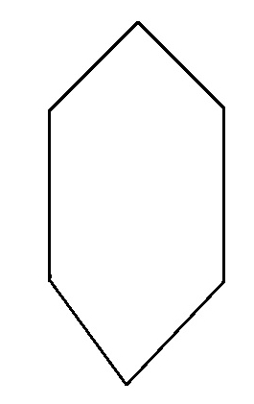

Fig 6.4 Basic Design of Boat

Our next step was to design a vehicle like image on the bridge, first our aim was to design more than two vehicles and make them moving in opposite direction on the bridge but it was so happened that both the vehicle like images had no space when they are crossing at the same point, it was impractical so we left out that idea and decided to design single vehicle. Frankly, we decided to design a bus because of its simplicity.

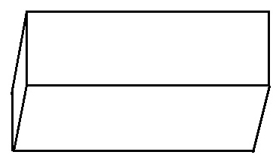

Fig 6.5 Basic Design of Bus

Rest of the things i.e. using the mouse and keyboard interface for the user was provided by writing separate functions and by calling the user defined functions in proper manner. The whole project gave some remarkable experience for us. From the beginning itself we had lots of confusions in our mind, whether the project would work as per our requirement or not. When we made an attempt to run the project as normal we encountered with many syntax errors, parameter mismatch and so on. Debugging those errors was not a difficult task for us because of the beautiful platform provided by eclipse. Once we made the corrections we execute the project at the first time the output was not exactly what we wanted so again made some changes in user defined functions to get the desired action.